https://www.youtube.com/watch?v=8zKuNo4ay8E

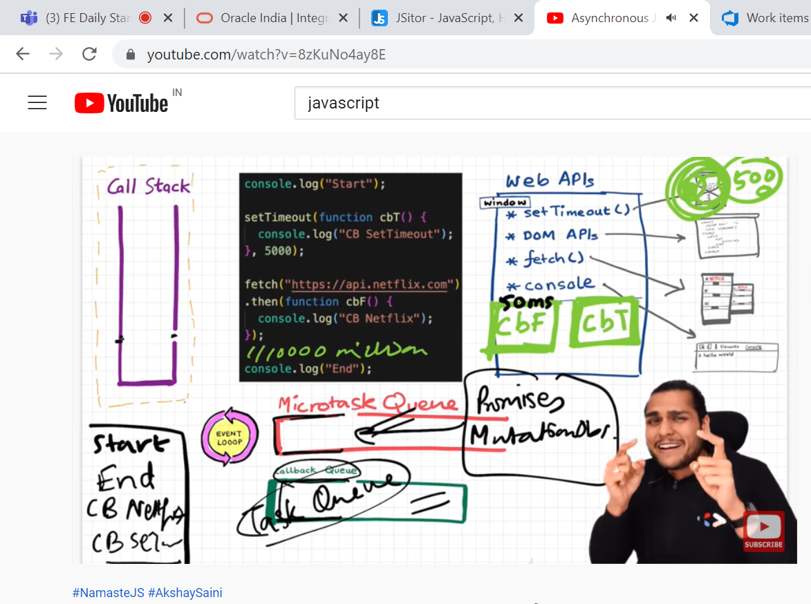

====== var === let === const===errors==

> let and const are hoisted. we cant use them before initialization is result of "temporal dead zone".

-> js use diff memory than global execution context to store let and cost. which is reason behind "temporal dead zone"

-> level of strictness ... var<<let<<const.

-> var //no temporal dead zone, can redeclare and re-initialize, stored in GES

->let //use TDZ, can't re-declare, can re-initialize, stored in separate memory

-> const //use TDZ, can't re-declare, can't re-initialize, stored in separate memory

-> **syntax error** is similar to compile error. while type and reference error falls under run time error.

-> **syntax error** ... violation of JS . while declare const variable but not initialize any value. Const variable should declared and initialize at same line and time.2. while re declared let variable

**-> type error** ... while trying to re-initialize const variable

->**reference error** ...   
 while trying to access variable which is not there in global memory. Which variable is not in scope and try to access let and const declared variable before initialization